CUSTOMER SHOPPING BEHVIOR ANALYSIS
- Project Overview
This project examines customer shopping behavior using a transactional dataset comprising 3,900 purchase records across multiple product categories. The objective is to identify meaningful insights related to spending patterns, customer segmentation, product preferences, and subscription behavior in order to support data-driven strategic decision-making.
- Dataset Summary
- Total Records:3900
- Total Features:18
- KEY VARIABLES
- Customer Demographics
- Age
- Gender
- Location
- Subscription Status
- Purchase Details
- Item Purchased
- Product Category
- Purchase Amount
- Season
- Size
- Color
- Shopping Behavior Metrics
- Discount Applied
- Promo Code Usage
- Previous Purchases
- Purchase Frequency
- Review Rating
- Shipping Type
- Data Quality
- The dataset contains 37 missing values in the Review Rating column.
- No other significant missing data issue were identified
- Exploratory Data Analysis (EDA) Using Python
The exploratory data analysis phase was conducted using Python to understand the dataset structure, assess data quality, and generate initial statistical insights.

- Data Preparation and Cleaning
Data Loading:
The dataset was imported into the Python environment using the Pandas library for efficient data manipulation and analysis.
Initial Exploration:
- df.info() was used to examine the dataset structure, including data types, non-null counts, and overall schema validation.
- df.describe(include=’all’) was applied to generate descriptive statistics for numerical variables, providing insights into central tendency, dispersion, and distribution patterns.
This initial exploration helped identify data inconsistencies, missing values, and potential preprocessing requirements before proceeding to deeper analysis.

Descriptive Statistics of Numerical Variables
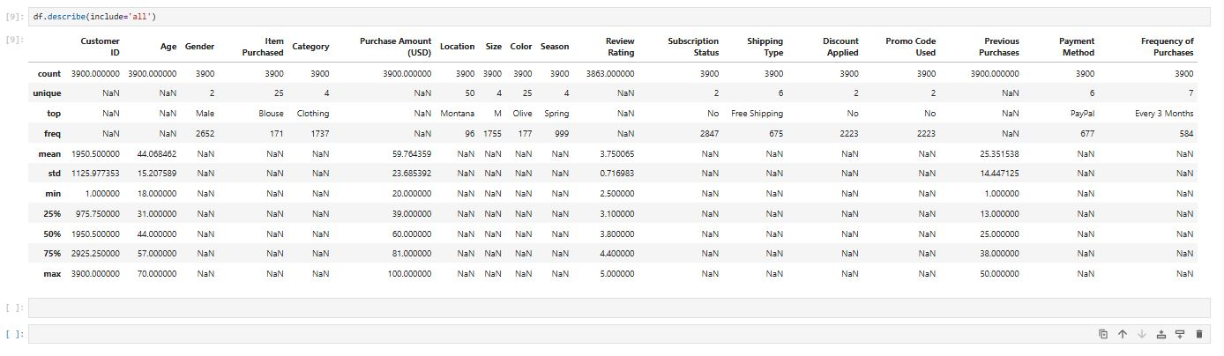

Missing Data Handling
A null value assessment was performed across all features. The dataset contained 37 missing values in the Review Rating column. These missing values were imputed using the median review rating within each product category, ensuring category-level consistency while minimizing the impact of outliers.
Column Standardization
All column names were converted to snake_case format to improve readability, maintain consistency with Python conventions, and support cleaner documentation and SQL integration.
Feature Engineering
- Age Group Creation:
An age_group feature was generated by binning customer ages into predefined intervals to enable demographic segmentation and comparative analysis.
- Purchase Frequency (Days):
A new feature, purchase_frequency_days, was derived from purchase-related data to quantify customer purchasing intervals in days. This metric supports behavioral segmentation and retention analysis.
Data Consistency Check
A redundancy check was performed between discount_applied and promo_code_used. Since both variables conveyed overlapping promotional information, promo_code_used was removed to eliminate duplication and maintain dataset efficiency.
Database Integration
The cleaned and transformed dataset was integrated with PostgreSQL by establishing a connection through Python. The processed DataFrame was then exported to the database, enabling structured SQL-based analysis and advanced querying.
- Data Analysis Using SQL (Business Transactions)
Following data preprocessing, structured analysis was conducted in PostgreSQL to address key business questions and extract actionable insights from transactional data.
- Revenue by Gender
Following data preprocessing, structured analysis was conducted in PostgreSQL to address key business questions and extract actionable insights from transactional data.
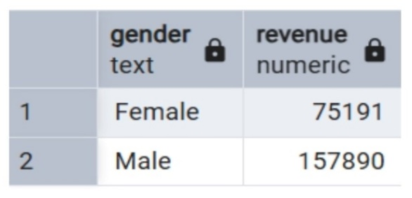
- High-Spending Discount Users
This analysis aimed to identify customers who used discounts yet recorded a purchase amount above the overall average transaction value.
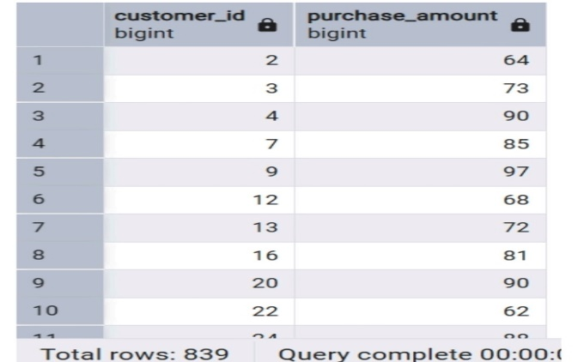
- Top 5 Products by Rating
This analysis identified the top five products with the highest average review ratings, based on customer feedback.
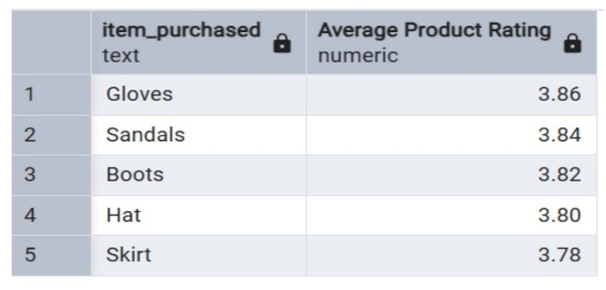

- Shipping Type Comparison
This analysis compared the average purchase amount between customers selecting Standard Shipping and Express Shipping.
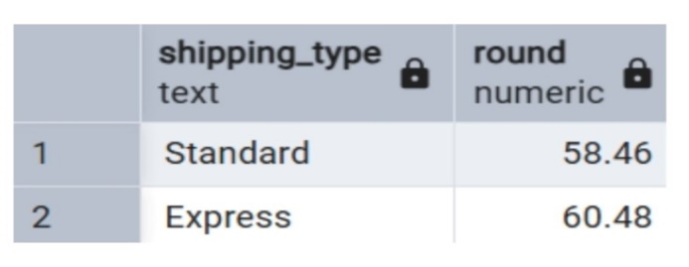
- Subscribers vs. Non-Subscribers
This analysis evaluated differences in purchasing behavior between subscribers and non-subscribers by comparing both average transaction value and total revenue contribution.
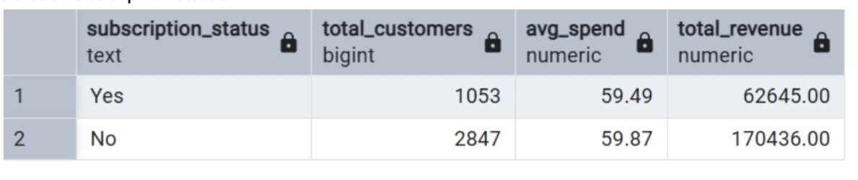
- Discount-Dependent Products
This analysis identified the five products with the highest percentage of discounted purchases, highlighting items that rely heavily on promotions to drive sales.
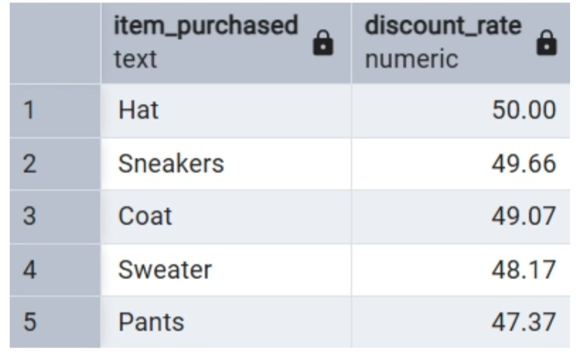
- Customer Segmentation
Customers were classified into New, Returning, and Loyal segments based on their purchase history to better understand engagement and retention patterns.
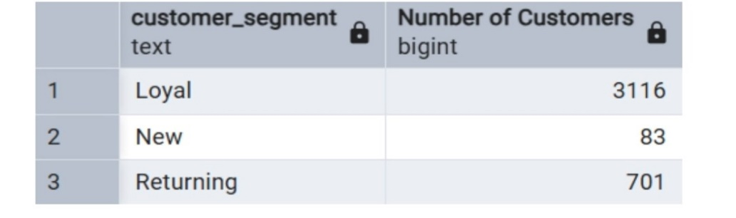
- Customer Segmentation
Customers were classified into New, Returning, and Loyal segments based on their purchase history to better understand engagement and retention patterns.
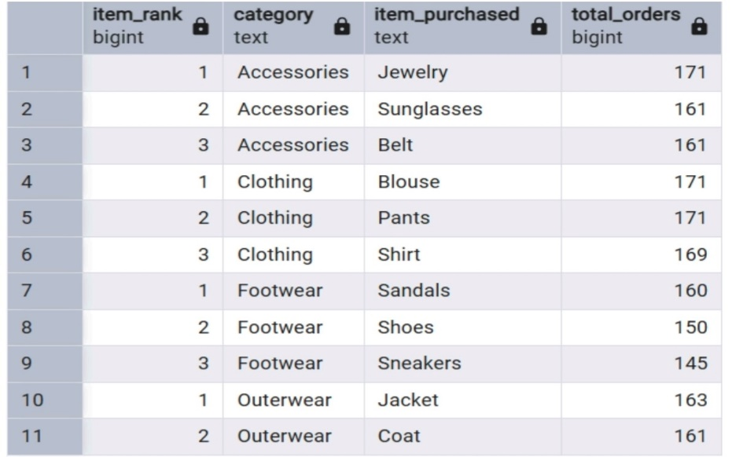

- Repeat Buyers & Subscriptions
This analysis examined whether customers with more than five purchases are more likely to be subscribers, exploring the relationship between purchasing frequency and subscription adoption.
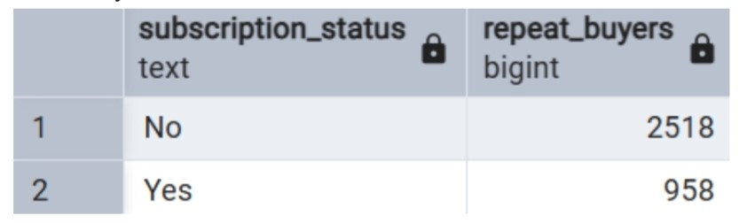
- Revenue by Age Group
This analysis evaluated the total revenue contribution of each age group, providing insight into which demographic segments generate the highest financial impact.
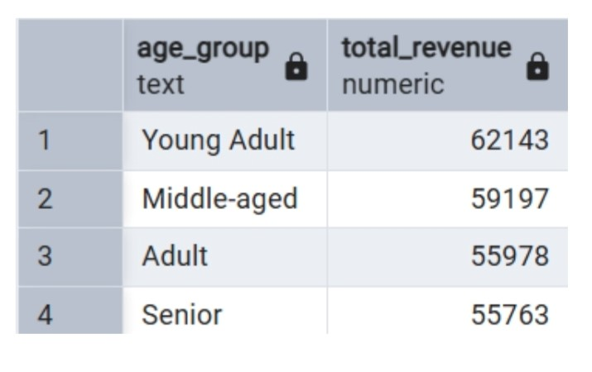
- Dash Board in Power Bi
Finally, we built in interactive Power Bi to present insight visually

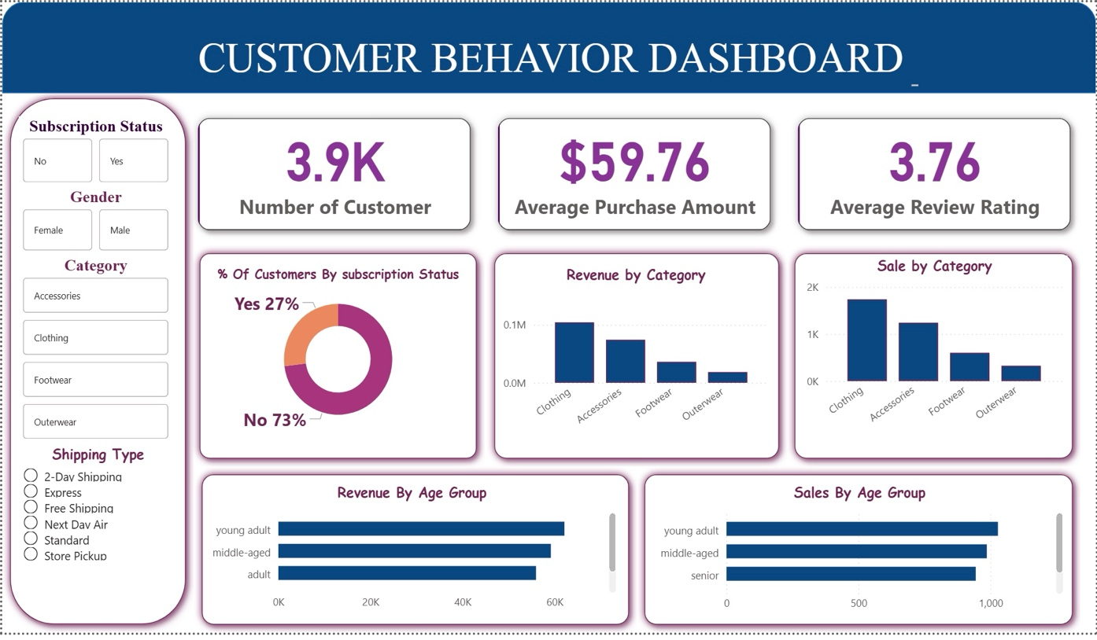
- Business Recommendation
1. Strengthen Subscription Value Proposition
Enhance the attractiveness of the subscription program by offering exclusive, clearly differentiated benefits (e.g., priority shipping, early product access, member-only discounts).
If subscribers do not demonstrate significantly higher average spend or retention, the program must be restructured rather than simply promoted.

2. Implement Tiered Loyalty Programs
Introduce a structured loyalty framework that incentivizes repeat purchases and transitions customers from Returning to Loyal segments.
Reward mechanisms may include milestone-based discounts, points systems, or personalized offers tied to purchase frequency.

3. Optimize Discount Strategy
Reevaluate discount-heavy products to determine whether promotions are driving sustainable growth or eroding margins.
Focus on:
- Reducing excessive discount dependency
- Testing controlled promotional experiments
- Protecting profitability while maintaining competitiveness
- Revenue growth without margin control is financially unstable.

4. Strategic Product Positioning
Prioritize top-rated and best-selling products in marketing campaigns and homepage placements.
Products that combine high purchase volume and strong customer ratings should receive premium visibility and inventory priority.

5. Targeted Marketing Campaigns
Allocate marketing resources toward:
- High-revenue age groups
- Express-shipping users (if correlated with higher average spend)
- High-frequency buyers likely to convert to subscribers
- Segmentation-driven marketing reduces acquisition costs and increases ROI compared to generic campaigns.

- Conclusion
This project demonstrates a complete end-to-end analytics workflow:
- Data cleaning and preprocessing in Python
- Structured business analysis using PostgreSQL
- Insight visualization through Power BI
- Strategic recommendations derived from data
More importantly, the analysis moved beyond descriptive statistics and focused on actionable business decisions.

